1. *Meta-analysis for Two-disease Association*

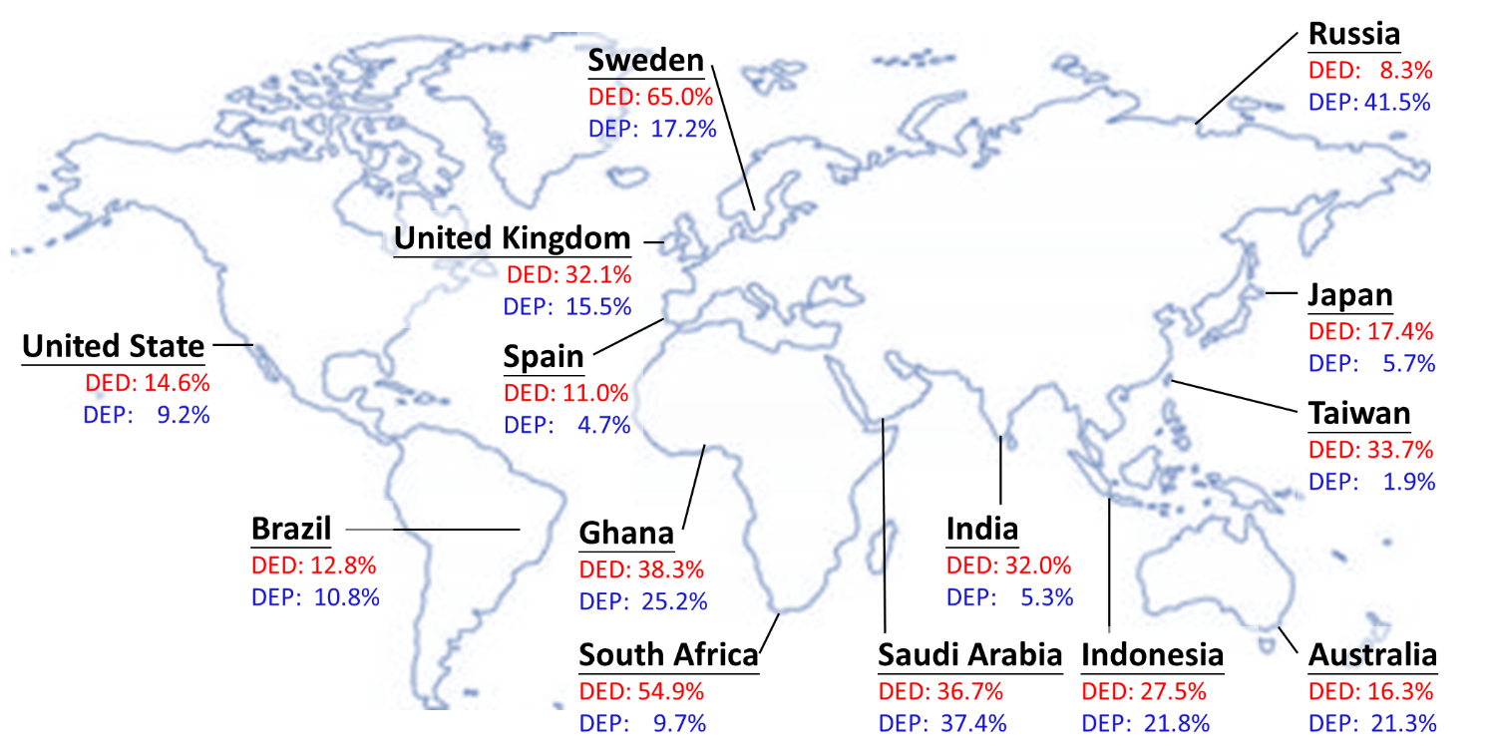

# Figure 1. Prevalence of Dry Eye Disease (DED) and Depression (DEP) in Various Countries.

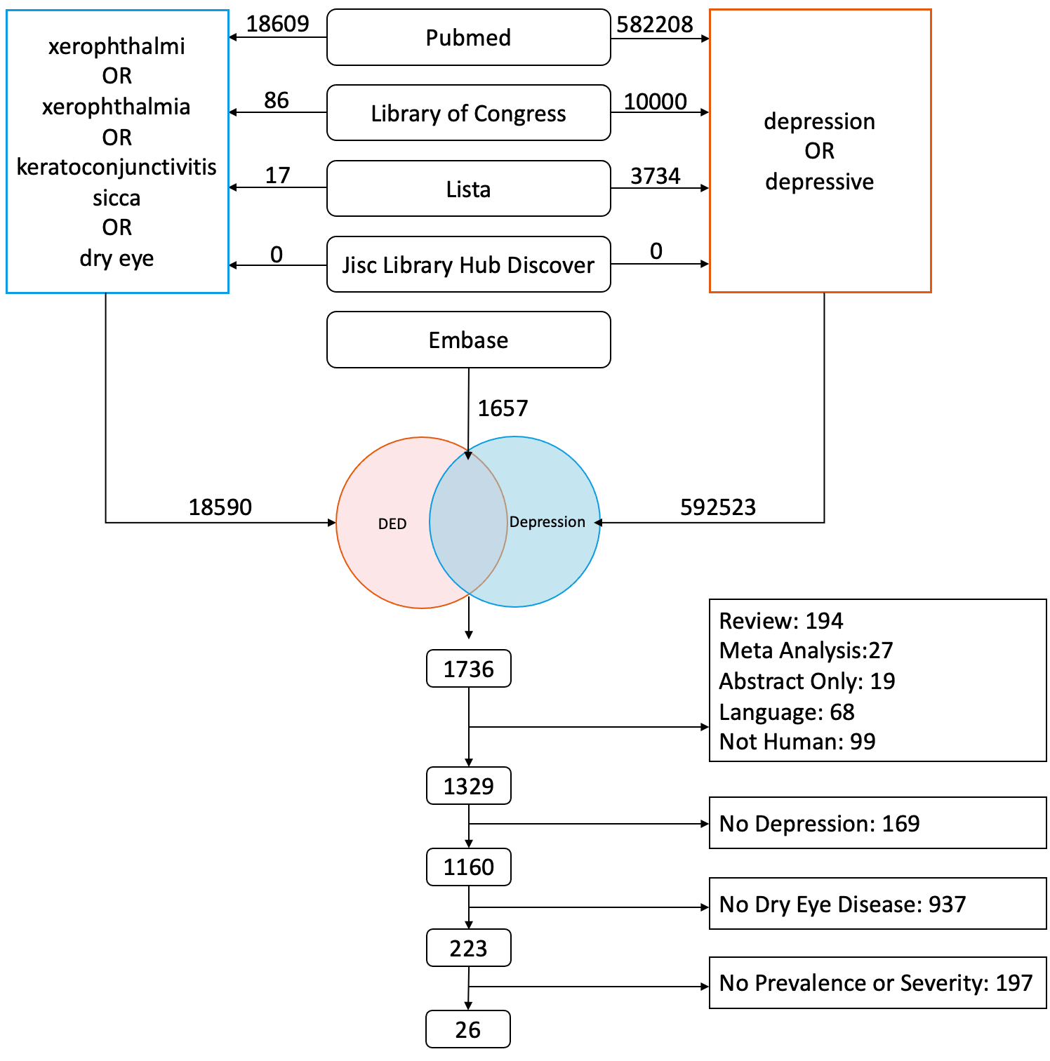

# Figure 2. Flow chart of study selection. Of these 1763 studies, 194 were reviews; 27 were meta-analyses; 19 were meeting abstracts; 68 studies had insufficient study relevance; 99 were not studies about humans; 1106 did not investigate dry eye disease (DED) and depression (DEP) patients; and 197 did not report relevant outcomes.

# 

# Figure 3. Association between standardized mean difference (SMD) of depression (DEP) severity in dry eye disease (DED) patients versus control group. DASS, Depression Anxiety Stress Scale; BDI, Beck Depression Inventory; SDS, Zung Self Rating Depression Scale; PHQ-9, Patient Health Questionnaire; SGDS, Short Geriatric Depression Scale.

# 

# Figure 4. Association between dry eye disease (DED) and depression in the presence of the severity standardized mean difference (SMD). (A) Association between Schirmer test (ST) score of DED in depression patients versus the control group. (B) Association between tear break-up time (TBUT) of DED in depression patients versus the control group. (C) Association between subjective questionnaire score of DED in depression patients versus the control group. CI, confidence interval; IV, inverse variance; Std. Mean difference, standardized mean difference. OSDI, Ocular Surface Disease Index; DEQS, 5-Item Dry Eye Questionnaire.

# 

# Figure 5. Subgroup Analysis of Meta-analysis. (A) Sensitivity analysis of the association between the prevalence of depression in dry eye disease (DED) patients versus the control group. (B) Sensitivity analysis of the association between the prevalence of dry eye disease (DED) in depression patients versus the control group. OR, odds ratio; CI, confidence interval; M-H, Mantel–Haenszel.

1. *Genetic Correlation Analysis in Taiwan Biobank (TWB) and UK Biobank (UKB)*

# 

# Figure 1. Genetic correlation of linkage disequilibrium (LD) score regression model in UK Biobank (UKB). RP, retinitis pigmentosa; DED, dry eye disease; OCD, obsessive-compulsive disorder.

# 

# Figure 2. Manhattan plots of genome-wide association studies (GWASs), scalable and accurate implementation of generalized mixed model (SAIGE), and conditional and joint association analysis (COJO). Green lines indicate *p* value=10-5, while red lines represent *p* value=10-2.9. TWB, Taiwan Biobank; UKB, UK Biobank. Red, dry eye disease; blue, depressive spectrum disorders. * SAIGE was only applied in the UK Biobank (UKB) due to the low case‒control ratio in DED (0.008).

# 

# Figure 3. Venn diagram of the top 200 single-nucleotide polymorphisms (SNPs) and related genes of genome-wide association studies (GWASs), scalable and accurate implementation of generalized mixed model (SAIGE), and conditional and joint association analysis (COJO). DED, dry eye disease; DEP, depression; UKB, UK Biobank; TWB, Taiwan Biobank.

1. *Bidirectional Causation by Mendelian Randomization in Taiwan Biobank (TWB) and UK Biobank (UKB)*

# 

# Figure 1. Scatter plot of the Mendelian randomization (MR) analysis: two-sample Mendelian randomization (TSMR). GWAS: genome-wide association study; COJO: conditional and joint association analysis. Red, dry eye disease (DED) resulting in depressive spectrum disorder (DEP); blue, depressive spectrum disorder (DEP) resulting in dry eye disease (DED). * SAIGE was only applied in the UK Biobank (UKB) due to the low case‒control ratio in DED (0.008).

# 

# Figure 2. Scatter plot of the Mendelian randomization (MR) analysis: one-sample Mendelian randomization (OSMR). GWAS: genome-wide association study; COJO: conditional and joint association analysis. Red, dry eye disease (DED) resulting in depressive spectrum disorder (DEP); blue, depressive spectrum disorder (DEP) resulting in dry eye disease (DED).

# 

# Figure 3. Odds ratio (OR) of leave-one-out (LOO) approach for heterogeneity analysis of two-sample Mendelian randomization (TSMR) using the inverse-variance weighted (IVW) method and major allele frequency (MAF) of single-nucleotide polymorphisms (SNPs). LOO omits instrumental single-nucleotide polymorphisms (SNPs) one by one to explore whether the MR estimates were disproportionately influenced by certain SNPs. GWAS: genome-wide association study; COJO: conditional and joint association analysis. Red, dry eye disease (DED) resulting in depressive spectrum disorder (DEP); blue, depressive spectrum disorder (DEP) resulting in dry eye disease (DED). * SAIGE was only applied in the UK Biobank (UKB) due to the low case‒control ratio in DED (0.008).

# 

# Figure 4. Odds ratio (OR) of leave-one-out (LOO) approach for heterogeneity analysis of one-sample Mendelian randomization (OSMR) using the inverse-variance weighted (IVW) method and major allele frequency (MAF) of single-nucleotide polymorphisms (SNPs). LOO omits instrumental single-nucleotide polymorphisms (SNPs) one by one to explore whether the MR estimates were disproportionately influenced by certain SNPs. GWAS: genome-wide association study; COJO: conditional and joint association analysis. Red, dry eye disease (DED) resulting in depressive spectrum disorder (DEP); blue, depressive spectrum disorder (DEP) resulting in dry eye disease (DED). * SAIGE was only applied in the UK Biobank (UKB) due to the low case‒control ratio in DED (0.008).